Among Us MOD Menu APK version 2020.11.17 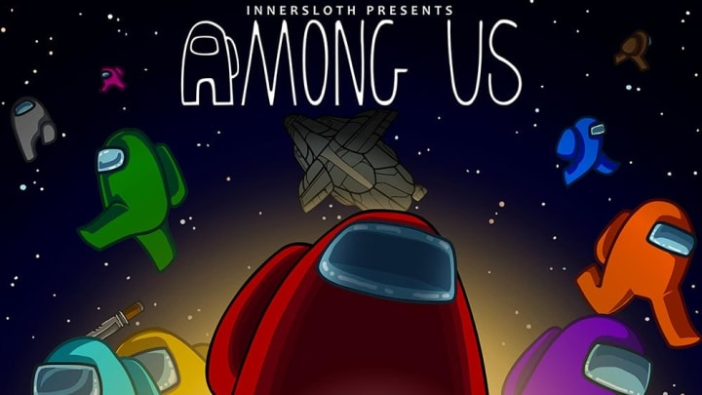

Among Us MOD Menu APK, the latest hacked version of Among Us which is available with many new features enabling you to win the game.

Among Us, a multiplayer game of teamwork and betrayal was designed and released by an American game studio InnerSloth in 2018.

It was brought in 2018 for the general public to use but it got worldwide fame and popularity this year in 2020 after the lockdown restrictions because of the global covid pandemic because of which people are restricted to get out of their houses to curb the pandemic.

If we talk about its prominence and reach, it has been downloaded over 100 million and has a rating of 4.5 on the Google Play Store, rated by the no. as high as 9 million reviewers which shows its extensive reach and popularity.

Information about Among Us Mod Menu APK

|  |  |
| --- | --- |
| Application NAme | Among Us Mod Menu |
| Version | 2020.11.7 |
| Download Size | 60MB |
| Downloads | 100,000,000+ downloads |
| Modder | TMKramers |
| Updated on | January 02, 2021 |
| Offered by | Innersloth LLC |
| Released on | June 15, 2018 |
| Get it on | Google Play Store |

Among Us Mod Menu APK App permissions:

Version 2020.11.17 can access

1. In-app purchases- Google Play billing service
2. Other- allow Wi-Fi Multicast reception, full network access.

What’s new

Balance Changes:

* Comms sabotage hides task arrows
* Comms red light no longer immediately responds to the correct position.

Bug Fixes:

* Fix camera flinging on security cams
* Fix inaccurate admin table on Polus
* Fix Polus panels reachable through walls
* Fix solo-complete reactor/seismic exploit
* Fix align engine exploit and softlock

**What is Mod Menu?**

It’s a game of teamwork and betrayal and can have 4 to 10 players each assigned either of the two roles imposter and crewmate.

It can have one to three imposters and the host will decide the exact number.

As you’ll enter in the game, all the players in any of the roles will be in a spaceship ready to depart. The crewmates are given various tasks to finish while the imposters’ task is to kill the crewmates before they’re done with their given work and win.

And imposters are required to get their work done mysteriously so that none of the crewmates will know of their intentions and activities.

In the last, if the crewmates can complete their tasks before getting killed or can recognise and pin point the imposters then they will win.

On the contrary, if the imposters can sabotage all the crewmates before the latter can finish their tasks without letting them know then the former wins.

It’s a thrilling game grounded on teamwork and betrayal, and the user will relish it certainly, once they start playing it.

**Features**

You can play this game either offline with your friend in a private room or online with randomly selected players across the world. To play with your friends, you need to create private rooms by sharing the game code with your buddies, and they can join using that code concomitantly.

There are three maps where you can play, which are The Skeld (a spaceship), Mira HQ (a headquarter edifice), and Polus (a planet base). The game will start as soon as it met the criteria of the required number of players then you’re free to choose the names for your avatar and your costume.

You can choose any one of these maps as per your wish. Then there are many other features like pets, skins, and hats from which you can choose anything for your character. Then the game will choose who will be the imposters and who will be the crewmates.

4-10 players can take part every single time in the game. The players are arbitrarily allocated the role of either a crewmate or an imposter and then they’re provided an alien spaceship, sky headquarters, or a planet base, where the game occurs. 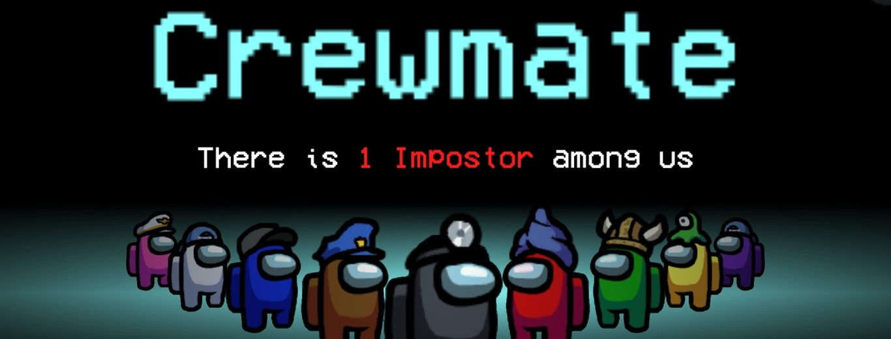

The imposter intends to murder the crewmates and/or destroy the spaceship. This game happens on a spaceship. Connect with your fellow players either in a private room or join a public room.

Three maps that are provided to the contenders are– the Skeld, Mira HQ, and Polus. Then the game will start once the number of players assigned to the room is met. Select your accessories and names for your epitome in the anteroom.

Then the game will decide by default who should be imposters and who’ll be crewmates. Then the game starts and the crewmates try to complete their allocated tasks while saving themselves from the imposters and the former tries to reveal the latter.

In contrast, imposters try to kill the crewmates enigmatically before they complete their tasks while using vents to escape.

The killed contenders can continue doing their tasks as ghosts and can communicate with the other fellow ghosts in the ghost chat. Other contenders can also communicate via chat during an unlimited number of meetings.

The updated among us game has many new features that enable an alive crewmate or imposter to see the ghosts also which will help you to be aware of the tasks which other contenders are doing so that you can vandalize them. In the earlier versions, only a ghost can see other ghosts. This will help you in winning, every time you play it and there are other new features too in Among Us Mod Menu APK.

Imposters have the upper hand on the cremates in the thing that they have the access to the vents. And, whenever a crewmate gets murdered then they turn into a ghost and can keep on completing their tasks and helping other crewmates while they remain invisible to the other contenders.

**Among Us Mod Menu Features**

**1.    Always Imposter**

In this game, you are allocated your role as an imposter or crewmate randomly. So, there’s no guarantee that you’ll get to become an imposter and everyone knows that it’s more fun to play as an imposter and you’re free to choose to be an imposter in Among Us Mod Menu.

**2.    Unlimited Meetings**

In Among Us the no. of meetings is fixed and that needs to be scheduled and if all of those are used up then the chances of reporting the imposters are shallow. But in Among Us Mod Menu, the no. of meetings is unlimited and you can call emergency meetings anytime to catch the imposters or to report a body.

**3.    Zero Kill Cooldown**

In this game whenever an imposter kills a crewmate then he has to wait for few seconds to restore the kill action but while waiting that imposter can get caught by the other contenders. But with Among Us Mod APK new feature, an imposter can enjoy double or triple kills easily without getting caught by the crewmates.

**4.    Wall Hack**

With this new feature, an imposter can cut across the walls and they don’t need to rely upon the vents to escape.

**5.    Speed/Fly Hack**

Imposters got a speed advantage over other contenders which will help them to escape easily.

**6.    Ghosts Visibility**

Imposters can easily be caught and tracking of the work of the ghost crewmates by the imposter is also easier since now ghosts are visible to the alive contenders. So, in both ways this feature is advantageous.

**7.    Light Hack**

You can see things in the darkness too as a crewmate so imposters won’t be able to kill your fellow mates taking advantage of the darkness.

**8.    Instant Kill**

This will allow killing the crewmates without letting them realize what thing hit them i.e., because of the instantaneous hitting of the object.

**9.    Mod Menu Unlocked**

A menu with multiple amazing features is now open for use.

**10. Unlimited Costumes/Skins**

You can choose an unlimited no. of costumes, skins, hats, and other things to make your experience more enjoyable and pleasing to the eyes.

**11. Always Win Mode**

This’ll let you win always in any of the roles even though this will lead to the decrement of enjoyment but it’s up to you if you want to use it.

**12. Fake Vote**

You can switch your vote during the voting process to confuse the other contenders.

How to Download Among Us MOD Menu APK for android: